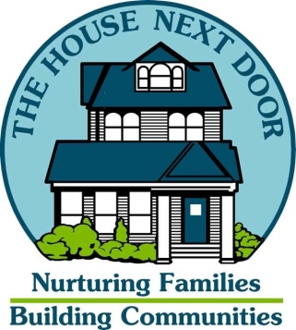

VOLUNTEER INFORMATION SHEET

Date:__________
Name: ___________________________________ Phone No. ____________________

Cell Phone No. ___________________ email address: _______________________

Address: ______________________________________________________________________

Emergency Contact Person: ________________________ Phone No. ____________________

Education: ___________________________________________________________________

Occupation: __________________________________________________________________

Skills that I can use as a volunteer for The House Next Door:

1. ______________________________________________

2. ______________________________________________

3. ______________________________________________

4. ______________________________________________

5. ______________________________________________

Possible volunteer opportunities that I may be interested in:

After-school tutoring _______ Special Events _______ Speakers Bureau _____

Data entry _______ Office/Clerical _______ Receptionist _______

Mentoring _______ Direct Service with Clients _______

Other: ___________________________________________________________________

My Areas of Interest and Skills:

Administrative _______ Education _______ Event Planning _______

Clerical/Office _______ Sports _______ Youth _______

Computer _______ Children _______ Tutoring _______

Counseling _______ Art _______ Repair Projects _______

Other: ___________________________________________________________

Any Physical Limitations: Yes_____ No _____

If yes, please specify: ________________________________________________

All volunteers who work directly with clients will be screened by The House Next Door.

References:

Name: ___________________________________ Phone ____________

Name: ___________________________________ Phone ____________

When would you be available? Days: ______________ Hours _____________

Availability:

Days of the Week: M T W Th F S Hours ____________________________

Signature of Volunteer: _______________________________________________

Interviewed by: ______________________________________________________

Placement Location: __________________________________________________

Please complete this form and mail or fax to:

The House Next Door
804 N. Woodland Blvd.
DeLand, Florida 32720
Fax: 386-734-0252

Or email the form to:

lgrant@thehnd.org

